**Order Ticket Extension Additional Feature Proposal**

Beside the auto switch the Open/Closed ticket status you told us you will going to change, we were designing to add two more feature on this Order Ticket system, but after we discuss with our boss, we have more features that we would like to add on, below is the list of the features, please let us know which feature you can complete and how long to take that feature to complete.

1. Display the last message (either from admin or customer) with date on the “My Orders” page on the frontend next to the “View Order” link. Use “Last Ticket Message” column to store the last message from backend (admin/system) or frontend (customer). This “Last Ticket Massage” column can be sorted.

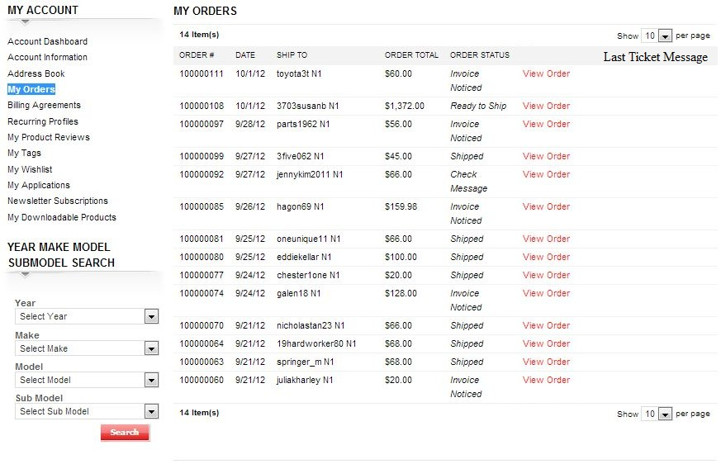

1. Make “My Orders” page “Order Status” column header to be sortable by dropdown list, just like the Order Grid page “Status” column on the backend.

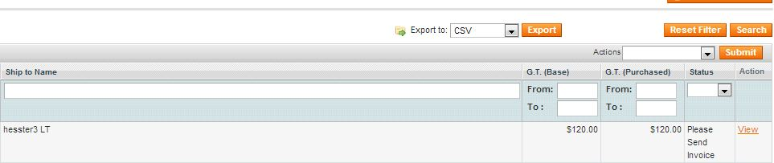

1. Make “My Orders” page “Ship To” column can be search by firstname or lastname, just like the Order Grid page “Ship to Name” column on the backend.



Please let us know which one you can finish and how long you can finish, and then we will discuss about the donation after your answer.